APPLICATION
Kindly click the tabs for details. Thank you.

Q1
What did we originally plan for the application?
VERSION 1 [FLOWCHART]
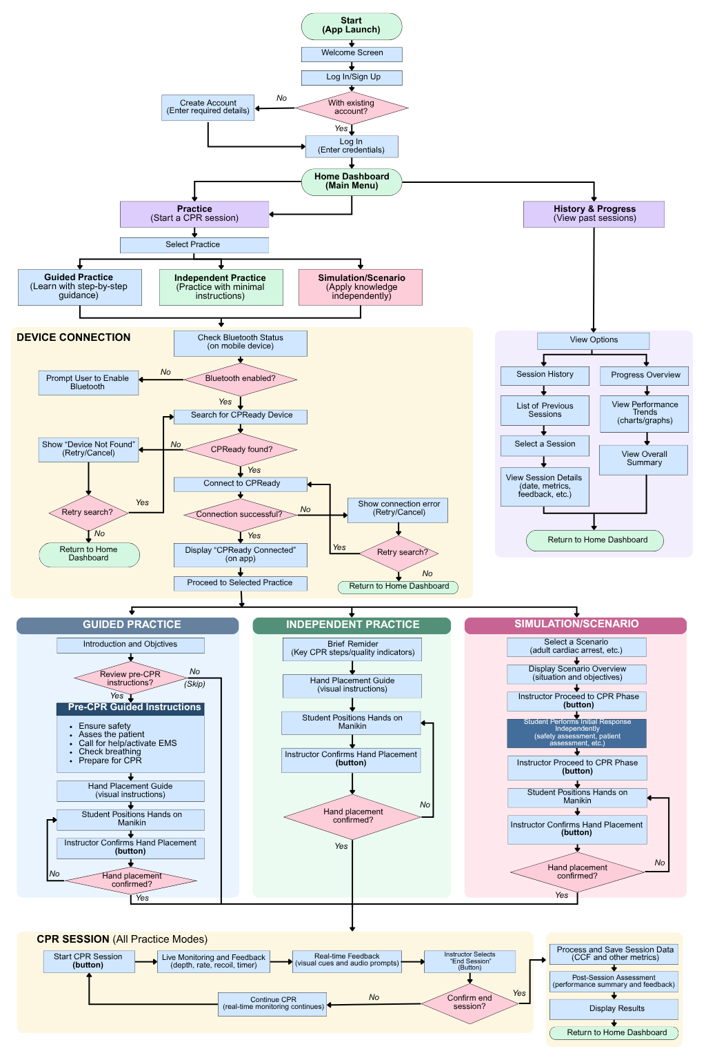

- Develop the CPReady mobile application using Flutter, primarily because one codebase could support the intended Android and iOS setup.
- Use the mobile application as the user-facing interface connected to the ESP32 through Bluetooth/BLE.
- Include three practice options: Guided Practice, Independent Practice, and Simulation/Scenario.
- In Guided Practice, provide step-by-step pre-CPR guidance, hand-placement guidance, and instructor confirmation before beginning CPR.
- In Independent Practice, provide minimal instruction before allowing the learner to practice more independently.
- In Simulation/Scenario, present an emergency situation in which the learner demonstrates the appropriate response and CPR.
- During CPR, display compression depth, compression rate, and chest recoil with corresponding real-time feedback; CCF would be processed and presented as part of the end-of-session results.
- Allow the instructor to confirm actions the system cannot automatically detect, such as hand placement, and to manually end the CPR session (same device as what the trainee is using, not separate).
- After each session, process and save performance data, display a post-session summary, and allow previous performance to be reviewed through History & Progress.
- The original flow also included account creation/log-in, although whether this remains necessary is subject to simplification.

What did Ma’am Gloperlyn suggest?
- Prioritize the physical device first before proceeding extensively with the application, since the application will depend on the finalized functions and outputs of the device.
- The application would primarily receive and display the information processed and transmitted by the ESP32.
- Establish clearly how the ESP32 and mobile application will communicate and exchange data before full application development.
- Consider placing immediate audio feedback on the physical device rather than depending entirely on the application for feedback.
- Further consult knowledgeable IT/electronics personnel regarding device-to-application integration and the technical requirements needed to implement the application.
- Treat additional systems, such as a separate web/admin platform, as secondary and consider them only if the primary device and mobile application can first be completed.

What concerns did we previously identify with Flutter?
- Learning curve – The application developers still need to learn Dart and Flutter before full development can begin.
- Bluetooth/BLE implementation – Communication with the ESP32 relies on Flutter BLE packages, whose compatibility and configuration need to be considered.
- Platform-specific configuration – Although Flutter uses one codebase for Android and iOS, some Bluetooth functions may still require separate Android/iOS setup.
- Development scope and time – The originally planned application contains several functions—including real-time CPR display and feedback, practice flows, session recording, and progress tracking—which may be difficult to fully develop and integrate within the limited development period.

What do we currently need the application to do?
- Connect and communicate with the ESP32 through Bluetooth/BLE to receive the CPR performance data generated by the device.
- Provide one core instructor-supervised CPR practice flow that allows the essential functions of CPReady to be used and tested without requiring multiple practice modes.
- Display the required CPR performance information and real-time feedback, particularly for compression depth, compression rate, and chest recoil.
- Manage and finalize each CPR session, including instructor-controlled session ending and presentation of the final CCF and performance summary.
- Record the necessary session data for post-session review and progress tracking.
* The initial prototype will prioritize one core instructor-supervised CPR practice flow instead of developing all three originally planned practice modes. If the essential device–application functions are successfully established and time permits, one simplified scenario may be added. Other nonessential features, such as account/login functions and extensive progress analytics, may also be simplified or removed.

Q2
What is the simplest application we can realistically develop that still fulfills CPReady’s necessary functions?
List the functions we actually need:
- ESP32–App BLE Connection – Connect to CPReady, receive transmitted CPR data, and provide basic connection/error handling.
- One Core CPR Practice Flow – Provide one instructor-supervised practice flow for using and evaluating CPReady.
- Real-Time CPR Feedback – Display compression depth, rate, and chest recoil with simple visual/audio feedback.
- Session Control and Results – Start/end the session and display essential post-session results, including CCF.
- Basic Data Logging and Review – Locally record the necessary session data and allow basic review of previous results.

Q3
FLUTTER FEASIBILITY

FINDINGS

REQUIREMENT |  | NOTES
Receive data from ESP32 | YES | - ESP32 broadcasting sensor data over BLE > Flutter app
Bluetooth/BLE communication | YES | - Standard library: flutter_blue_plus
Real-time data display | YES | - BLE "notify" characteristics push data to the app as it changes
CPR feedback (visual/audio cues) | YES | - Standard app UI/logic  - Flutter has no unique limitation
Store session data | YES | - shared_preferences for simple key-value  - sqflite/hive for structured session history
Work offline | YES | - BLE is local/offline by nature (no internet needed to talk to the ESP32)
Android + iOS from one codebase | YES
Buildable by your team in 3 months | 50/50 | - Realistically yes, but only if we scope the app down. Not a polished, full-featured app.

REALISTIC TIMELINE

PHASE | TIMELINE | WHAT HAPPENS?
Learn the framework basics | 2–3 weeks | - Language syntax, UI basics, navigation, state management fundamentals
Learn BLE specifically in that framework | 1–2 weeks | - Scanning, connecting, reading/writing characteristics, notifications  - BLE bugs are often silent/hard to debug
Build core app screens, wire up real ESP32 data | 3–4 weeks | - Connection screen, live feedback screen, basic session storage
Integration testing with actual hardware | 2 weeks | - BLE connection drops, permission issues (especially Android 12+ runtime BLE permissions), device-specific quirks
Buffer / polish / defense prep | 1–2 weeks | - Fixing what broke during integration, cleaning UI, preparing demo

Q4
POSSIBLE ALTERNATIVES - Most Practical: Flutter

CRITERIA | FLUTTER | REACT NATIVE | NATIVE ANDROID (KOTLIN) | MIT APP INVENTOR (LOW-CODE)
Bluetooth/BLE | flutter_blue_plus | React-native-ble-plx  * works for some, but problems occur with maintenance/version compatibility | BluetoothGatt  * works for some, but problems occur with maintenance/version compatibility | Works via BLE extension, but forum reports show recurring issues:  - reconnection failures  - device-model compatibility quirks  - permission errors
Real-time data |  |  |  | Functional for simple cases, but less reliable for tight timing feedback (users report dropped/duplicated notifications)
Android |  |  | Native
iOS |  | Needs Mac + Xcode either way | Not native (would need separate Swift app) | Weaker iOS BLE support than Android
Data storage | (sqflite/hive) | (AsyncStorage/SQLite) | (Room) | Limited to TinyDB-style storage, not ideal for structured sessions
Ease of coding | Moderate (Dart, but simple syntax) | Moderate (JS/TS likely more familiar if team knows web dev, but in our case, no) | Harder (more verbose, Android-specific concepts) | Easiest (drag-and-drop blocks)
Learning curve | Medium | High (must know how to code JavaScript) | High (must be familiar with Android/Kotlin) | Very low
Team familiarity |  |  |  | Trivial to pick up, but hard to build something polished/robust
ESP32 compatibility |  |  |  | Works but flaky. Forum threads full of reconnection/compatibility bugs
Development time (3-month capstone) |  |  |  | Risks unreliability in the exact BLE behavior CPReady depends on (live feedback needs consistent notifications)
Overall practicality

Q5
CURRENT RECOMMENDATION
Platform we currently recommend: Flutter

Why?
Our team's specific situation:
- two beginners, one with an Arduino/C-style background
- no JavaScript experience, and
- tight three-month deadline

Flutter works in our favor because it fully supports BLE (via flutter_blue_plus), real-time data display, local session storage, and offline use, all of which CPReady needs. It also builds Android and iOS from one codebase, which matters because our two-person timeline can't realistically absorb building a separate iOS app on top of Android.

React Native offers no real advantage here since neither of us knows JavaScript.
Native Android is ruled out for having the steepest learning curve with no iOS support.
We also ruled out MIT App Inventor because its BLE reliability issues (documented reconnection failures and dropped notifications) directly undermine the one thing CPReady depends on: consistent real-time feedback.

Minimum application features we recommend:
- Scan for and connect to the ESP32 device over BLE
- Receive and display live CPR metrics (e.g., compression rate/depth) as they're transmitted
- Simple visual/audio feedback indicating whether compressions are within the correct range
- Save a basic record of each session (date, duration, summary result) locally on the device
- Basic connection status/error handling (e.g., "device not found," "disconnected")

Features we think can be simplified/removed:
- Cloud sync or account/login systems - not needed for a local single-device training tool, and adds real development time we don't have
- Detailed analytics/history graphs across many sessions - a simple pass/fail or basic summary per session is enough for the prototype stage
- Multi-user profiles - likely out of scope for a 3-month build
- Any non-essential UI polish (animations, themes, etc.) until the core BLE + feedback loop is working reliably

Biggest technical concern:
- We think it's whether the connection stays stable and notifications arrive consistently and fast enough for real-time CPR feedback to feel accurate rather than laggy or dropped.
- This is the part most likely to eat unplanned debugging time, based on what we saw across every platform we researched (even the more mature options have documented notification/connection quirks)

What needs to be confirmed before development?
- The exact BLE service/characteristic structure the ESP32 will use to transmit data (UUIDs, data format, update frequency)
- How often the ESP32 will send data (update interval), since that determines how "real-time" the feedback can realistically feel.
- What CPR metrics the ESP32 is actually capable of measuring and sending (rate only? depth too? recoil?), since that defines the minimum feature set above.
- Whether a single ESP32 unit will be available for the app team to test against consistently during development, since BLE integration can't really be debugged without the real hardware.

Q6
QUESTIONS WE HAVE IN MIND:

- For our proposed setup, what would be the most practical complete pathway for sending CPR information from the sensors and ESP32 to the Flutter application? Specifically, which processing should be performed by the ESP32 and which, if any, should be left to the application?
- What specific information should the ESP32 transmit to the application for each CPR indicator and session function, and how should these different data be organized so the application can correctly identify and display them?
- How should we configure the BLE communication between the ESP32 and Flutter for continuous CPR monitoring—including the service/characteristic structure, data format, and transmission/update frequency—to provide responsive feedback without unnecessarily overloading the ESP32 or application?
- What connection failures or transmission problems should our application be designed to detect and handle during a CPR session, and what should the application do when they occur to prevent incomplete or misleading session data?
- Considering our simplified application—one instructor-supervised CPR practice flow, real-time depth/rate/recoil feedback, session control, final CCF/results, and basic session recording—is this device-to-application architecture technically sufficient? What functions would you recommend adding, changing, or simplifying before we begin development?

